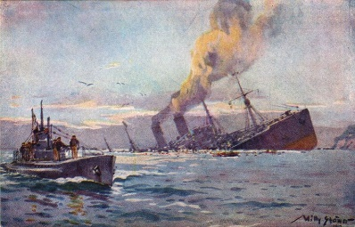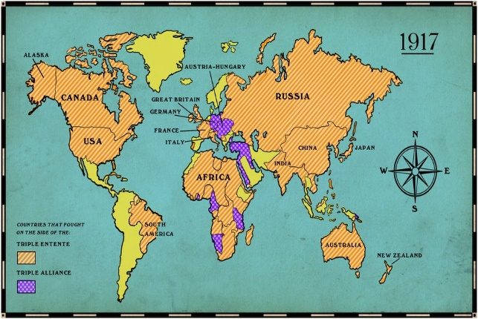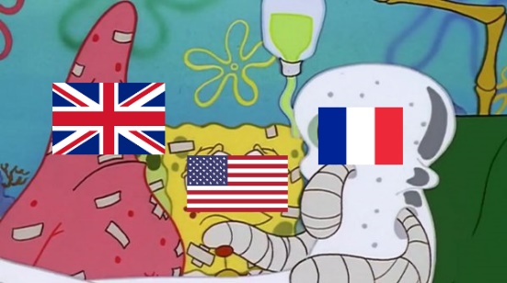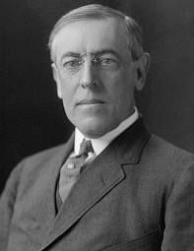

**MEET THE TEAM:**

**MS. COACH EDWARDS….**

**Matching; Guess Who; Puzzle Solving**

**Team leader; #1 Organizer; super amazing**

5 Fun Facts:

1. Remember your fun facts must be from the correct time period!! WWI 1914 – 1919
2. During WWI, Alcohol was illegal. Yikes.
3. President Wilson passed the 19th amendment, which granted women’s suffrage.
4. Uncle Sam did not become the symbol of the U.S. until WWI.
5. Soldiers were nicknamed “doughboys.”

The United States did not gain or lose any territory during WWI since the war was fought in Europe.

All of your countries DID. Your map must be hand drawn.

Your key must be well-explained and detailed.

DO A GOOD JOB!

* The war began in 1914, but the U.S. did not join until 1917. The U.S. tried to remain neutral and isolated.
* In WWI, the U.S. was part of “The Allies.” The U.S. worked with Great Britain and France.
* The U.S. fought with these countries because they were Germany would not stop participating in unrestricted submarine warfare
* Germany also tried to convince Mexico to invade us. This scandal is known as the Zimmerman Note

The President of the United States of America during World War I was Woodrow Wilson…….

Listen to me talk about him in class.

Here you will write two awesome, grammatically correct, detailed paragraphs.

There are the colors on the United States flag; red, white, and blue. Red represents hardiness, Blue embodies justice, and White symbolizes purity. There are 13 strips for the 13 original colonies in America, and the 50 starts represent the 50 states.

**USA**