Name: __________________________________________________ Date: ________________ Period: ___
Reading Through History:
Directions: Read the information and answer the questions that follow.
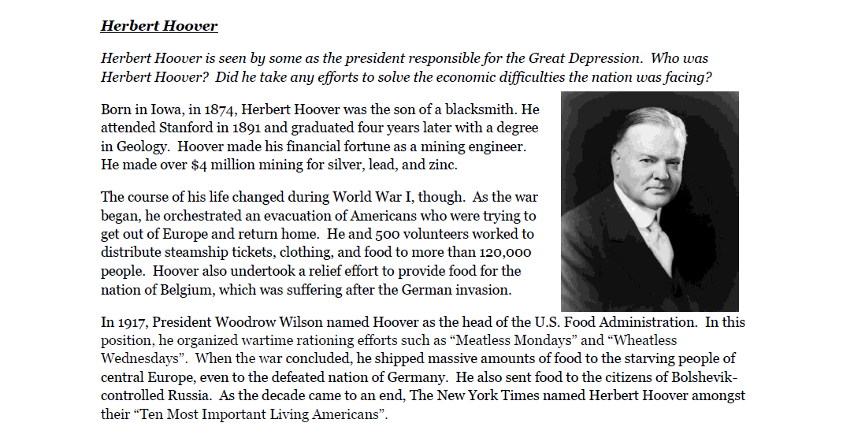
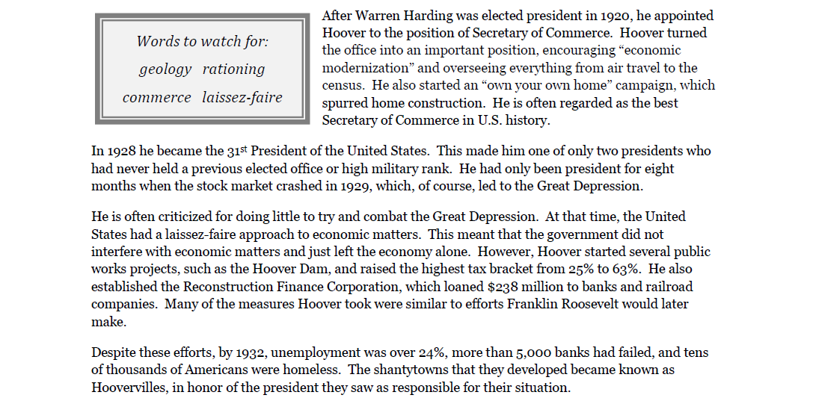
Directions: Select the choice that completes the statement or answers the question.

1.______ Which of the following best describes how Herbert Hoover became successful?
a. Hoover bought and sold on the stock market, making himself a small fortune.
b. Hoover patented his invention, the vacuum cleaner, which became a household item.
c. Hoover mined for silver, lead, and zinc, making over $4 million.
d. Hoover owned more property than anyone in New York City, making millions from rental fees.
2.______ Which of the following best summarizes Herbert Hoover’s activities during
World War I?
a. Hoover served in the military, rising to the rank of general. He gained fame for winning several important battles.
b. Hoover organized an evacuation of Americans and relief efforts in several European countries.
c. Hoover was Assistant Secretary of the Navy throughout the entire war.
d. Hoover was not involved in the war effort; he was too occupied running his business.

3.______ Which of the following events occurred only eight months after Herbert Hoover
became president?
a. the stock market crash c. the use of the first atomic bomb
b. the outbreak of World War II d. the conclusion of World War I

4.______ Why is Herbert Hoover often criticized?
a. Many felt he tried to do too much to combat the Great Depression.
b. Many felt he was more concerned with preserving his own fortune than helping people.
c. Many felt he was attempting to eliminate the election process, so he could remain president.
d. Many felt he did too little to try and combat the Great Depression.

5.______ Which of the following statements is inaccurate?
a. Hoover started several public works projects, such as the Hoover Dam.
b. Hoover started the Federal Deposit Insurance Corporation to insure banks.
c. Hoover raised the highest tax bracket from 25% to 63%.
d. Hoover established the Reconstruction Finance Corporation.

Directions: Fill in the blanks below to create complete sentences.
- Herbert Hoover attended _________________________ in 1891 and graduated four years later with a degree in Geology.

- Hoover also undertook a relief effort to provide food for the nation of Belgium, which was suffering after the _____________________________ invasion.

- Hoover organized wartime rationing efforts such as “_____________________” and “Wheatless Wednesdays”.

- Hoover shipped massive amounts of food to the starving people of ________________________________, even to the defeated nation of Germany.

- The ____________________________________ named Herbert Hoover amongst their “Ten Most Important Living Americans”.
- Herbert Hoover is often regarded as the best ___________________________ in U.S. history.

- Hoover is one of only two presidents who had never held a previous _______________________ or high military rank.

- At that time, the United States had a ______________________________ approach to economic matters.

- The shantytowns that developed during the Great Depression became known as ____________________.

- Hoover is still viewed by some as “the president who caused the ________________________”.

Directions: Answer the following questions in the space provided. Attempt to respond in a complete sentence for each question. Be sure to use correct capitalization and punctuation!

- Who appointed Herbert Hoover as the Secretary of Commerce?

- What position did Woodrow Wilson appoint Hoover to in 1917?

- When was Hoover elected president?

- Where did Hoover send food during, and after, World War I? (Which nations are mentioned?)

- Why did they call the shantytowns “Hoovervilles”?

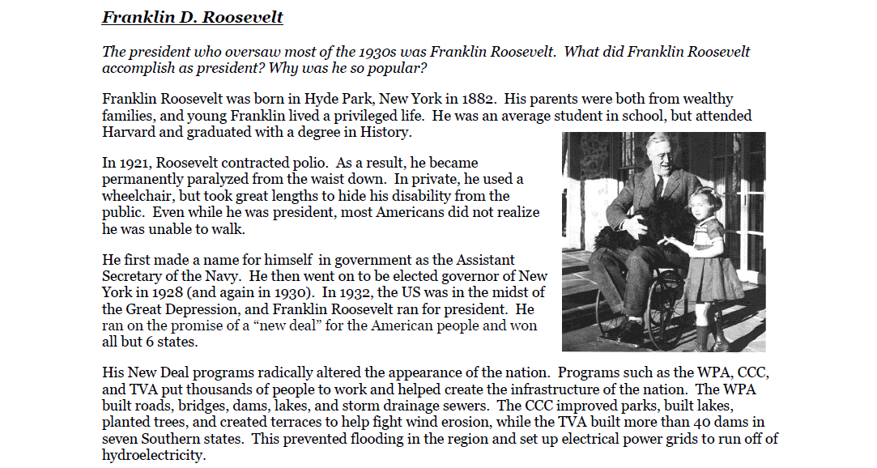

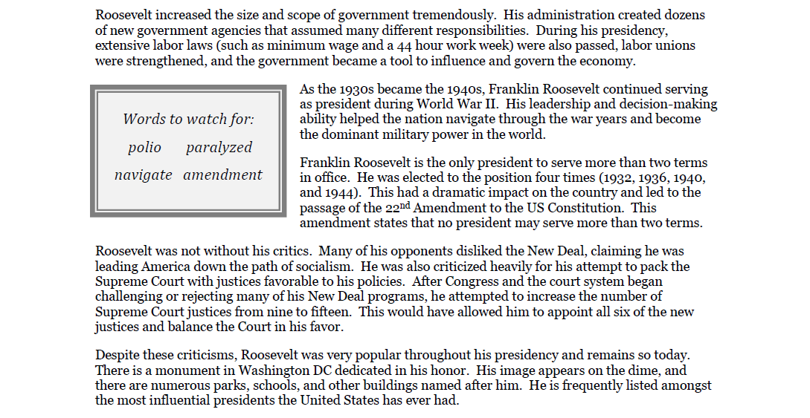

Directions: Select the choice that completes the statement or answers the question.

1.______ Which of the following best describes a long term effect that polio had on Franklin Roosevelt?
a. Roosevelt stuttered frequently because of his fight with the illness.
b. Roosevelt was permanently paralyzed from the waist down.
c. Roosevelt had great difficulty sleeping because of the illness.
d. Roosevelt had several scars across his neck and face from treatments.

2.______ Which of the following best summarizes Roosevelt’s early political career?
a. He served as the mayor of New York City and then as a senator.
b. He was a member of the House of Representatives for many years.
c. He became a general in the US Army and then served as Secretary of State.
d. He was the Assistant Secretary of the Navy before becoming governor of New York.

3.______ Which of the following best describes the purpose of many of Roosevelt’s New Deal programs?
a. The New Deal programs put thousands of people back to work and created infrastructure for the nation.
b. The New Deal programs were intended to ensure that Roosevelt would win re-election several more times.
c. The New Deal programs were designed to keep Americans occupied so they would not think about their problems.
d. The New Deal programs were intended to keep America out of a possible war in Europe.
4.______ Which of the following is an accurate statement about Franklin Roosevelt?
a. Roosevelt remains the only president to travel to Europe while he was in office.
b. Roosevelt was the first president to live in the White House.
c. Roosevelt became the only president to serve more than two terms.
d. Roosevelt is the only president to have gotten married in the White House.
5.______ Which of the following has Roosevelt been criticized for?
a. He attempted to eliminate the election process, wanting to declare himself president for life.
b. He frequently held lavish parties in the White House, which many thought was improper during the Great Depression.
c. He negotiated with enemy nations and frequently gave in to their demands.
d. He attempted to raise the number of Supreme Court justices, so he could appoint six new justices.

Directions: Fill in the blanks below to create complete sentences.

- Franklin Roosevelt was an average student in school, but attended _________________________ and graduated with a degree in History.

- In private, Roosevelt used a ___________________________, but he took great lengths to hide his disability from the public.

- Roosevelt was elected ___________________________ of New York in 1928.

- The WPA built __________________, bridges, dams, lakes, and storm drainage sewers.

- Roosevelt’s administration created dozens of new government agencies that assumed many different __________________________.

- As the 1930s became the 1940s, Franklin Roosevelt continued serving as president during ______________________.

- Franklin Roosevelt was elected president _____________________ times.

- The _________________________________ states that no president may serve more than two terms.

- Many of Roosevelt’s opponents criticized his New Deal programs, claiming he was leading America down the path of ___________________________.

- Despite these criticisms, Roosevelt was very _______________________ throughout his presidency.

Directions: Answer the following questions in the space provided. Attempt to respond in a complete sentence for each question.

- Who did not realize that Roosevelt was unable to walk throughout his presidency?

- What did Roosevelt promise when ran for president?

- When was Roosevelt elected president (which years)?

- Where was Roosevelt born?

- Why did Roosevelt hope to appoint six new Supreme Court justices?

