African Empires
Directions: As you read through the different documents about empires in Africa, fill in the below chart.
Type of Evidence: | Specific Evidence: | Geographic Area: | What it told Historians:
Example: written source | The writings of Al-Bakri | The Kingdom of Ghana | Information about the history of the Kingdom of Ghana
Directions: Answer the following questions.
- What did the Kingdom of Ghana trade their gold for?

- What was the second largest empire in the world in the 13th to 15th centuries?

- How did the majority of Africa become Muslim?

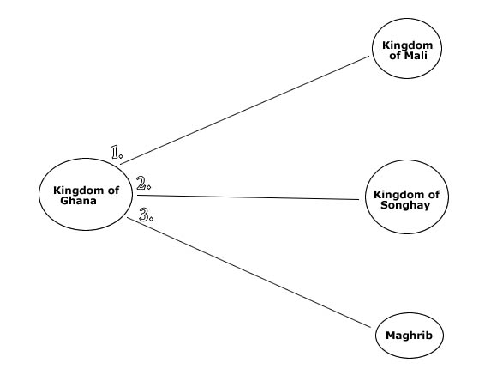
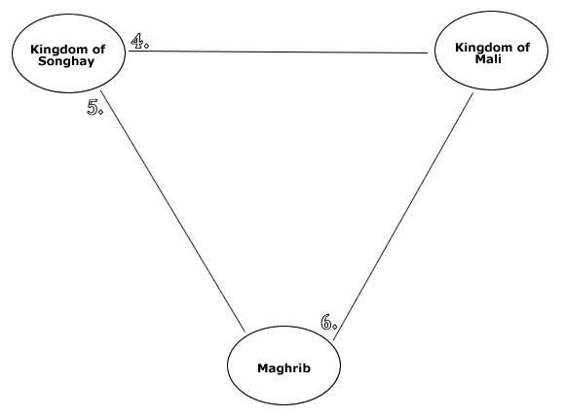
Directions: Using the graphic organizers below, fill in one connection or relationship between each of the areas.

