Name: _____________________________________________________ Date: ______________ Period: _____
American Revolution Crossword Puzzle
Directions: Using the key terms in your notes and textbook, complete the following crossword puzzle.
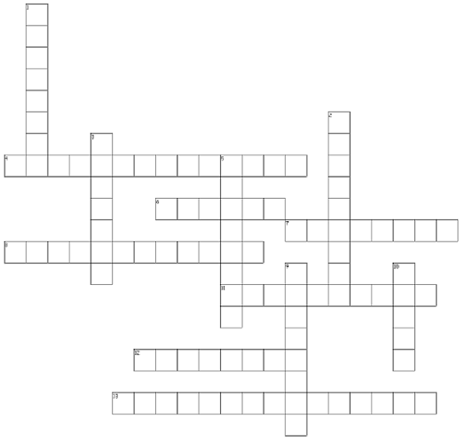
Across  4. Parliament has complete control over American colonies  6. King of England during American Revolution  7. American won battle that persuaded France to help  8. First 10 amendments  11. First President of the U.S.A.  12. "No taxation without representation"  13. Power is divided between the federal government and the states | Down  1. He influenced U.S. 1st amendment, Freedom of Speech  2. Wrote the Declaration of Independence  3. Constitutional Convention's floor leader  5. Location of British surrender to American soldiers  9. Number of colonies  10. Beliefs in natural rights directly influenced the U.S. Constitution

