Renaissance Crossword:
At the bottom of the page are a sense of clues to discover the key terms that fit in the crossword puzzle. Use your book, notes, and previous knowledge to fill in the puzzle.
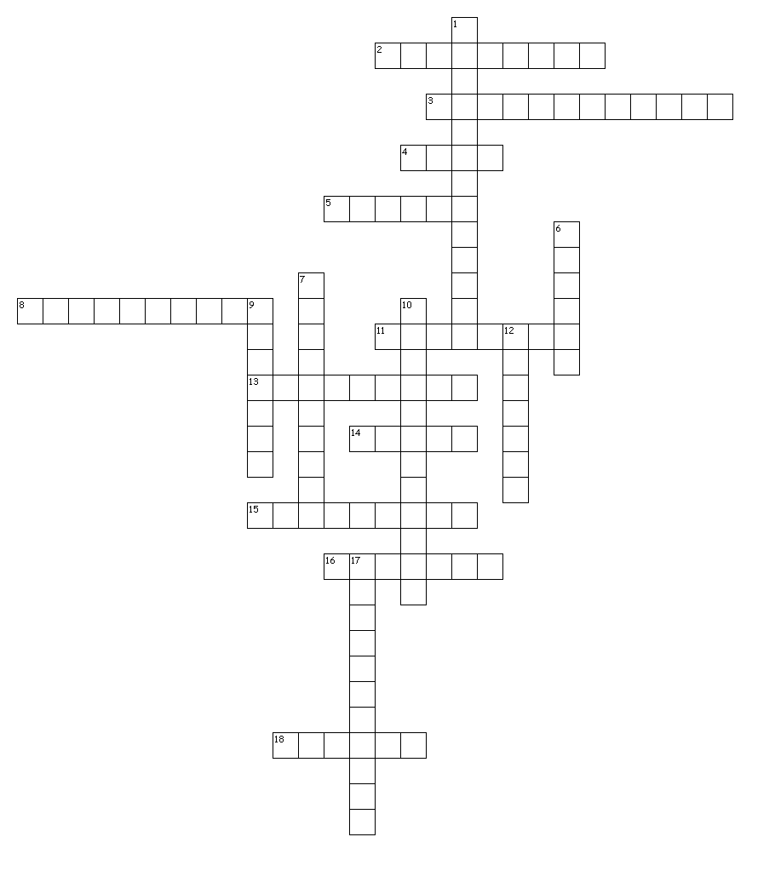
Across  2. Printed the first completed edition of the Christian Bible  3. "melancholy genius"  4. "a day for a meeting"  5. 95 Theses  8. Everday language of ordinary people  11. Painted the Mona Lisa & The Last Supper  13. Declared the Church of England independent of Rome  14. emphasized experimentation and observation  15. emphasized human reasoning  16. Assembled an astronomical telescope  18. Richest Merchant family of Florence | Down  1. Made Italy a favorable setting for the Renaissance  6. Introduced the world to gravity  7. Subjects such as grammar, rhetoric, poetry, and history  9. Blended Christian and Classical styles  10. Sun-centered model of the universe  12. Expressed by focusing on the human experience in the world around them  17. Protestants who rejected infant baptism

